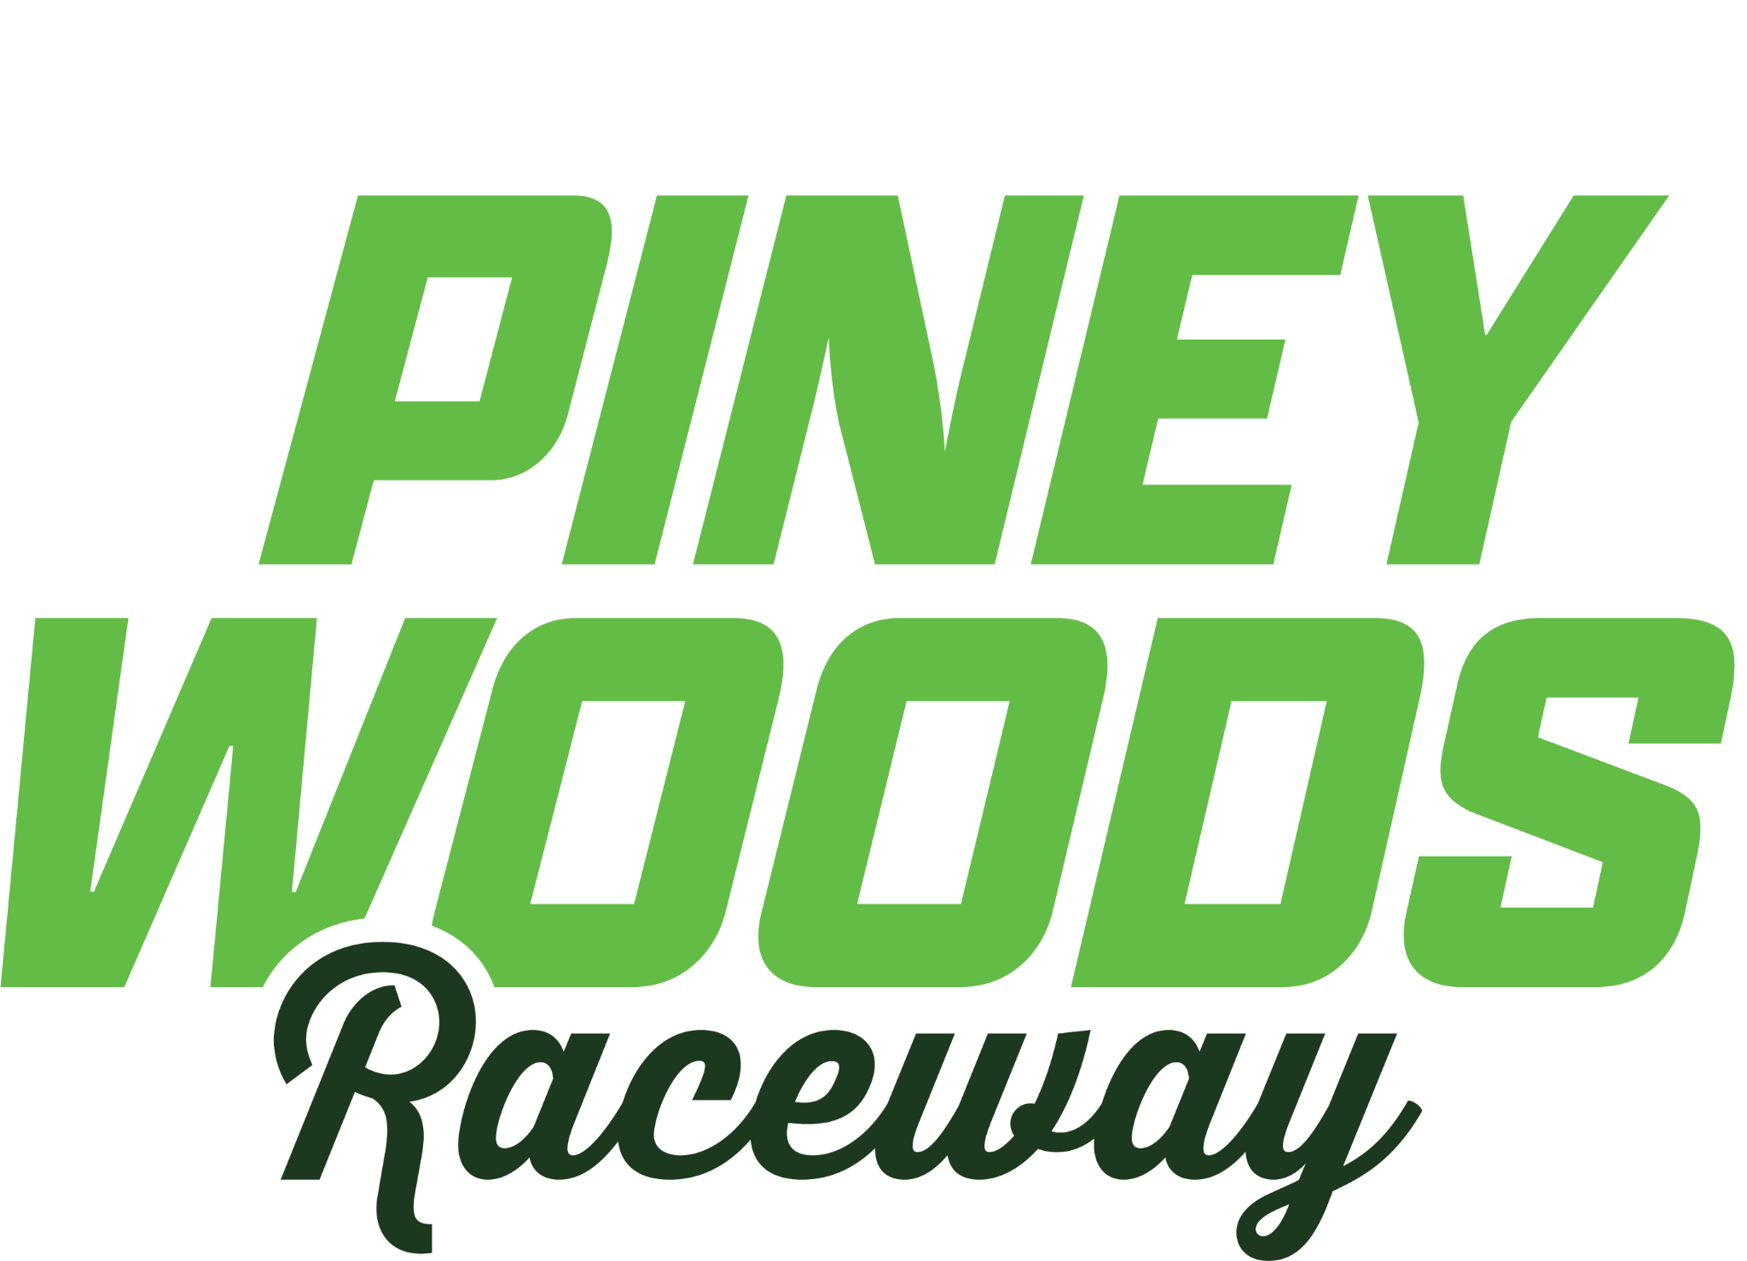

Outlaw Sprint

10th scale 2WD off-road buggy-based stock or carbon fiber or similar material chassis

Scale appearing sprint body, wing, and roll cage

Any 2-pole 540 sensored brushless motor

Open ESC

Intent

All PWR Dirt Oval Series races will run under the current rules at the time of the race. Class rules are a work in progress and will be amended as needed. First and foremost, it is the SPIRIT of these rules the completely describe what you can do in this class. If it doesn’t say you can, assume that you cannot.

Chassis
- Any 1/10th scale buggy type chassis, Custom Works, Triple P or Velocity carbon fiber chassis allowed
- Mid and Rear Motor chassis allowed
- Added weight must be inside or on top of the chassis, steel, brass or any metal type
- Aluminum, brass or steel hub carriers are allowed, front and rear

Suspension
- Independent suspension only
- Aftermarket shocks and springs allowed, Big Bore and threaded OEM Shocks are allowed
- Limiting of shocks is allowed inside the shock
- Adjustable rear arms are allowed
- You may run any spring combination from any manufacture, one spring per wheel

Transmission
- Motor may be mid or rear engine
- Single speed gearbox transmissions only
- May use gear or ball differentials
- Drivetrain upgrades are allowed (MIP, Proline, Avid Slipper Eliminators will be allowed)
- Any spur gear or pinion ration combination is allowed

Electronics
- Electronics can be mounted on the left or right but within main chassis plate only
- Any 540-size motor any turn is allowed, sensored with any timing setting
- Motor cooling fans allowed
- Any type of ESC, can be ran in any mode

Battery
- 7.4V or 7.6 LiHv / 2S LiPo Batteries, maximum charge voltage 8.60V
- Battery may be centerline, offset to either side and in laydown or standup positions
- Batteries should be charge in a safe LiPo charging bag
- Any multi-channel radio system and servo allowed
- No AVC, GYRO or additional traction control devices allowed

Tires
- Rubber Tires Only, any compound and combination
- PWR will be open tire rule for outlaw sprint car
- Must use standard 2.2” wheels

Body and Cage
- Sprint cars must have a scale appearing roll cage.
- The cage must be symmetrical left to right and mounted level to the chassis.
- Roll cages not appearing realistic or designed to direct air or create a competitive advantage will not be permitted.
- All cage and body components such as cage, bumpers, nerf bars, hoods, side panels, tanks, etc. must be mounted on the centerline of the cage.
- Chassis may not extend outside of the side panels by more than 1/4" on either side.
- No lexan or any other material may be mounted to nerf bars, bumpers, cage, wing, or any other part of the car that will trap, alter, or direct air flow for the purpose of gaining an aerodynamic advantage.
- Must have appropriate openings on both sides of cage in driver compartment, forward portion of side panels can be no taller than highest point of hood.
- Additional material may be used/added to either side of the side panel openings to replicate a scale appearing driver, but a decal or image of driver must appear on this additional material.

Bumpers
- A flat, curved, or tubular front bumper (or combination of) must be utilized and may not be used to direct air or create downforce.
- Scale appearing side nerf bars must be used on both sides of the car (nitro rules will differ).
- A scale appearing rear bumper must be always utilized. Bumpers and nerf bars must be made of a shock absorbing material.

Tail Tank
- A traditional scale appearing rounded style three-dimensional rear fuel cell must be used.

Nose Area
- A molded or fabricated nose piece may be used and is defined from the front axle forward to the front bumper.
- Front bumper may not extend more than 3” from front axles.
- Nose piece (any lexan) must be at least 3/8" back from the leading edge of the front bumper.
- Maximum width of nose piece/bumper is 3.75"

Hood Area
- A scale appearing hood must be used and is defined as beginning at the front axle and ending at the front of the driver cockpit.
- The hood must be symmetrical from left to right.
- The hood must be tall enough and wide enough to allow room for a scale engine intake and air cleaners (no unrealistically low or flat hoods).
- Nose piece may not extend above the cage down tubes or an imaginary line connecting the down tubes if the cage is a split design.

***Note that the hood and nose piece can be one piece or multiple pieces for the purpose of easy access to electronics and suspension but are defined as above for purposes of aero rules.

Front Wing
- For front wing dimensions see appropriate wing drawing pdf at www.dirtoval.com
- The front wing center section may not extend in front of the front bumper.
- Front wing mounts may be made of Lexan but may not exceed 1.75” in length and 1.75” in height and may not extend in front of or behind the center section of the wing per DODC National Rules.

Top Wing
- For top wing dimensions see appropriate wing drawing pdf at www.dirtoval.com
- For top wing dimensions see appropriate wing drawing pdf.
- Top wing minimum height at leading edge: 5.00" from bottom of chassis.
- Top wing maximum height at leading edge: 6.50" from bottom of chassis.
- The center section and side panels must be made from at least 3 separate pieces of polycarbonate, carbon, or aluminum material.
- All corners and edges must be rounded and free of sharp edges.
- Main and Front wings must be mounted so that they are centered on cage, no offset wings.
- Wing center sections must have all 4 corners set at 90-degree angles, no canted or angled panels.
- Wings must also be mounted level from side to side.
- The center section of wing may not extend beyond the leading or trailing edge of side panels.
- Side panels must have braces that hold side panel rigid at 90deg. to the center section during race conditions.
- Two braces are required from top of the center foil to the left sideboard and one brace is permitted below the center foil to the right sideboard.
- Braces can be a maximum of .750" wide and front edge of front brace must be no more than 1.5” back from side panel leading edge.
- Side Panels may have front, back, top, and bottom turnouts of no more than .375" and are included in max dimension.
- Flat foil center sections will be allowed a .250” turndown at the leading edge.

Headers
- Three-dimensional scale appearing exhaust headers must appear on both sides of car in “engine area.

